

1202 Parkway Drive

Goldsboro, NC 27534

P.O. Box 10135

Goldsboro, NC 27532

(919) 759-9214 Tel

(919) 759-0410 Fax

**FOR IMMEDIATE RELEASE**

**GOLDSBORO, N.C. –** **Geographic Technologies Group (GTG)** Lauderhill, FL Implements Next Generation GIS Browser 10/17/12

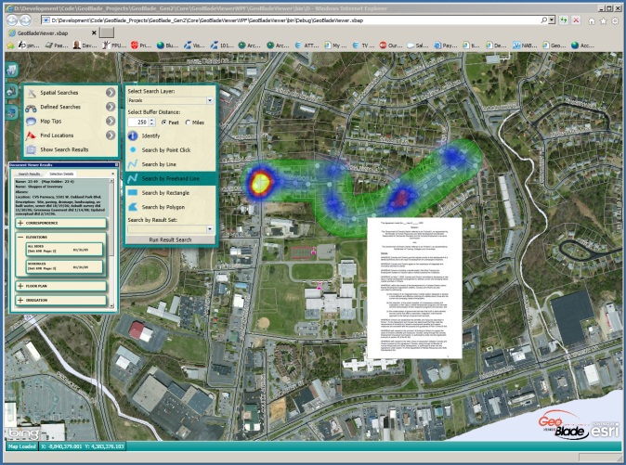Like most organizations, Lauderhill, Florida, needed to disseminate GIS data and integrate non-spatial investments through a user friendly GIS portal.  To that end, Lauderhill has implemented GeoBlade Vantage Points from GTG.  Joan Fletcher, GIS Manager for the City of Lauderhill, points out; “our city has invested significant funds in GIS and other IT investments.  We knew that a user-friendly GIS portal that integrates technology was our answer.  However, finding the perfect solution required due diligence.”  Ms. Fletcher selected GeoBlade Vantage Points (GVP) because it was designed to be an all-inclusive portal.  GVP utilizes Windows Presentation Foundation (WPF) for a “Web 2.0” user experience that is second to none.  The ArcGIS Server based GVP integrates any corporate IT database with ease.  In the case of Lauderhill, it also incorporates document management – presenting pertinent documents to the end users.  The application integrates visualization tools from Google and Bing, has plug-ins for reverse 911, twitter, crime analysis, emergency dispatch, routing, and a host of other functions.  Curt Hinton, President of GTG, points out; “GeoBlade Vantage Points is the most complete enterprise GIS tool on the market.  We have spent millions of dollars on our backend integration toolset that allows GVP to tie to any technology.  We are excited about assisting organizations like Lauderhill in achieving success by utilizing GIS as the de-facto portal into their enterprise data.”

GTG is the winner of the 2011 Esri International Mobile GIS Application Award and the 2012 Special Achievement in GIS Award.  GBV webinar dates and sign ups can be found at <http://www.geotg.com/webinar/GVPWebinarNov.html> For more information contact David Holdstock at 888-757-4222 or email [dholdstock@geotg.com](mailto:dholdstock@geotg.com).

**About Geographic Technologies Group, Inc. (GTG):**

GTG is a full-service local government GIS consulting company offering specialized experience in the planning, design, implementation, and procurement of geo-technologies. GTG has unmatched technical GIS capabilities, demonstrated successes, international experience, and a reputation for successfully implementing the right solutions. GTG develops GIS products that spatially enable various enterprise solutions and integrates an organization's IT investment via a common interface. GTG also offers stand-alone products for land management, public safety, public access, touch screen technology, and utilities.

GTG has more than 700 clients located throughout North America and Europe and serves all levels of government as well as the private sector. To support our clients, GTG maintains four offices located across the United States: Headquarters in North Carolina, and regional offices in Texas, Florida, Ohio, and California.

Additional information may be obtained by contacting Geographic Technologies Group, Inc. at 888-757-4222 or you can access our website at www.geotg.com.

####