Press Office

**U.S. Department of Homeland Security**

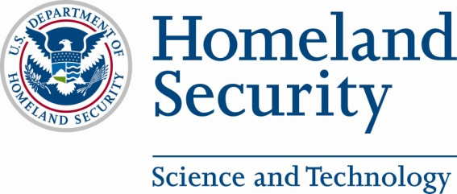

Media Advisory

August 14, 2012

Contact: DHS S&T Press Office at (202) 254-2385

**DHS TO PRESENT NEWEST RADIO TECHNOLOGY TO STATE/LOCAL EMERGENCY RESPONSE AGENCIES AT APCO CONFERENCE**

***DHS marks conclusion of Multi-Band Radio pilots with delivery of radios to pilot partners***

**WASHINGTON, DC—** On August 21, 2012, the Department of Homeland Security’s Science and Technology Directorate (S&T) will mark the end of the pilot phase of its Multi-Band Radio initiative with the presentation of radios to participating state and local emergency response agencies. Multi-band radio technology will allow police officers, firefighters, and other emergency management and response personnel to communicate with partner agencies regardless of radio band. The presentation will take place at the Association of Public Safety Communications Officials (APCO) Conference in Minneapolis, MN.

Fifteen emergency response agencies took part in the multi-band radio pilots conducted across the nation, culminating in its transition to the emergency response community. S&T’s Multi-Band Radio initiative has sparked industry development of multi-band radio technology, now commercially available and being marketed by several manufacturers.

**Tuesday, August 21**

WHAT: Media availability to announce the conclusion of the final pilot of DHS Science & Technology Directorate Multi-Band Radio initiative.

WHO: DHS Science and Technology Directorate, Director of the Office of Interoperability and Compatibility, Dr. David Boyd;

Representatives of state and local emergency response agency partners

WHEN: 10:00a.m. CDT, Tuesday, August 21, 2012

WHERE: Association of Public Safety Communications Officials (APCO) Conference*

The Minneapolis Convention Center

1301 Second Ave. South

Room 200-J

Minneapolis, MN 55403

***\**** *Media must register in advance for the APCO Conference (free) at* <http://apco2012.org>.